**Silo Construction Cost Reduction**

|  |  |  |
| --- | --- | --- |
| 4. | A step-by-step example demonstrating the MATLAB solution. Also  provide an instruction’s manual to run the MATLAB program to obtain  the MATLAB solution demonstrated in the example. |  |
| 5. | Detailed results section. Present results and graphs of your analytical and  MATLAB solution in this section, compare and discuss your results  including their physical interpretation. |  |
| 6. | Flowchart of the solution methodology. |  |
| 7. | 3D figure. |  |
| 8. | Conclusions. In this section include conclusions related to this project,  summary of problem and results, the difficulties that you faced during  this project and how you overcame those difficulties. |  |
| 9. | Contribution. In this section clearly state the contribution of each group  member. Generic statements such as ‘each group member contributed  equally’ are not acceptable answers. |  |

**TABLE OF CONTENTS**

|  |  |  |
| --- | --- | --- |
| **Sr. No.** | **Deliverable** |  |
| 1. | Objectives and introduction of the problem. |  |
| 2. | A step-by-step by-hand solution. Clearly state the assumptions and  values that you use for the solution. |  |
| 3. | A well commented MATLAB code with line-by-line explanation. This  part must include the explanation of the commands, functions, and  toolboxes used. |  |

(1):OBJECTIVES AND INTRODUCTION

INTRODUCTION:

As December is approaching which is the sowing month of wheat and farmers will be sowing the seeds soon in December. The wheat crop will get ready to be harvested in the month of March. The farmers are planning to build a storage place for the wheat. They have decided to build a silo to store it because silo is most preferable as it is safe and commercially economical and useful storage thing.

OBJECTIVES:

1.We have to make a silo of two different volumes (2000 and 4000 m^3)

2.We have to minimize the price of making silo

3.We have to provide the least radius and height in order to minimize cost

4.Final is to develop a program that will help the farmers to choose their own height and radius for the silo according to their need and output the cost of construction.

5.We will make a “**SILO WITH BASE”.** In order to avoid the leakage of the grains and other reason is to avoid water from entering the silo from ground. 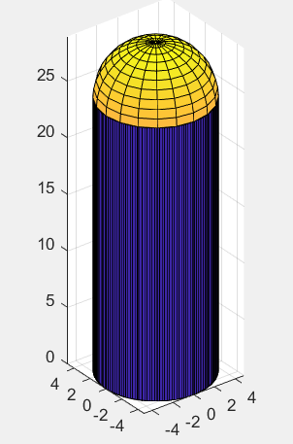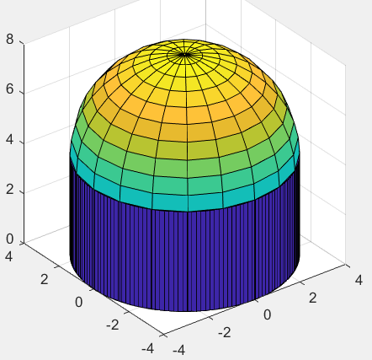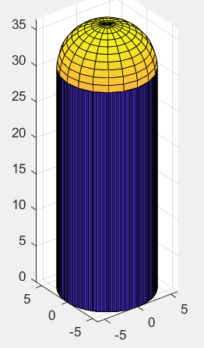

3D FIGURES

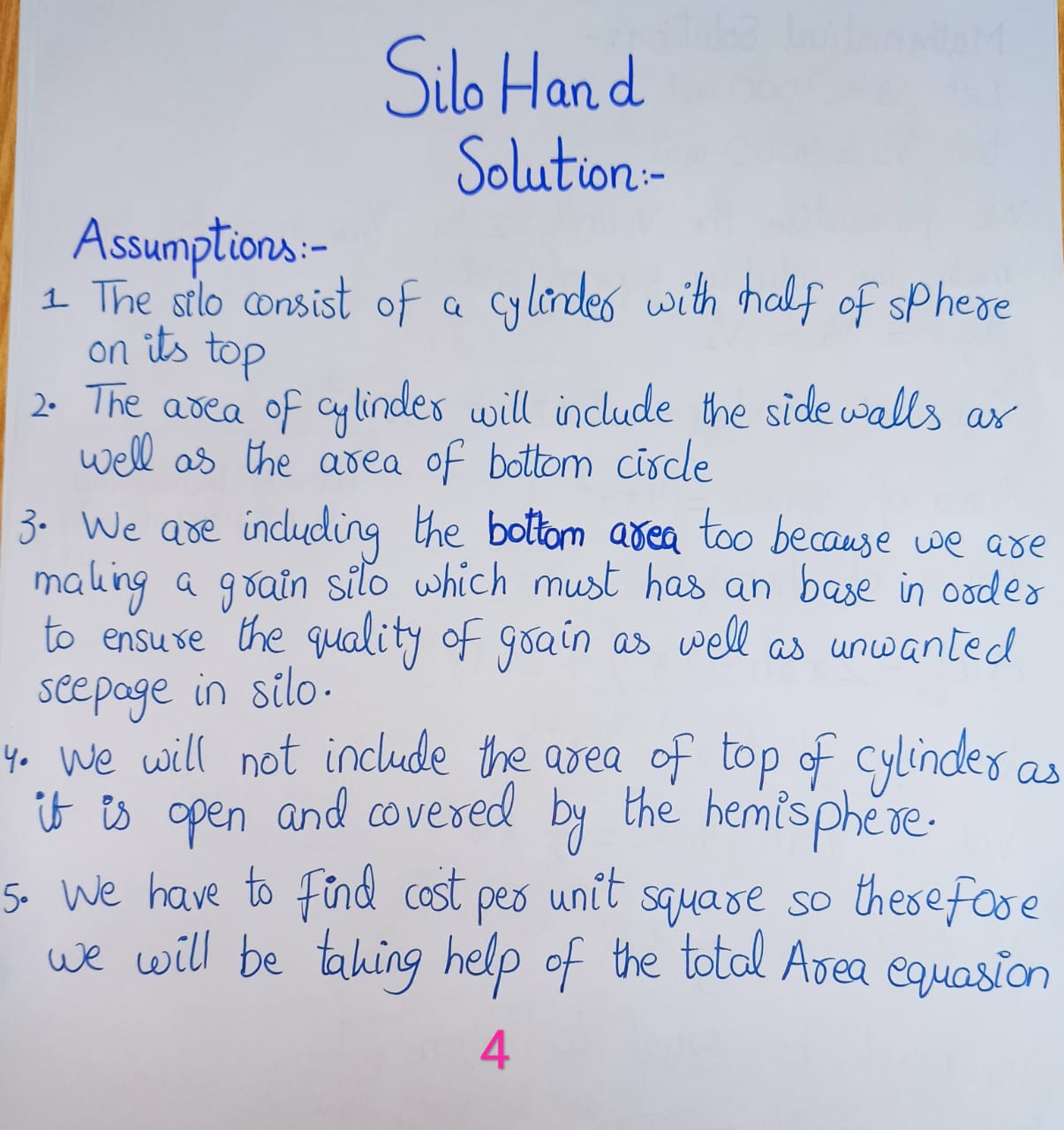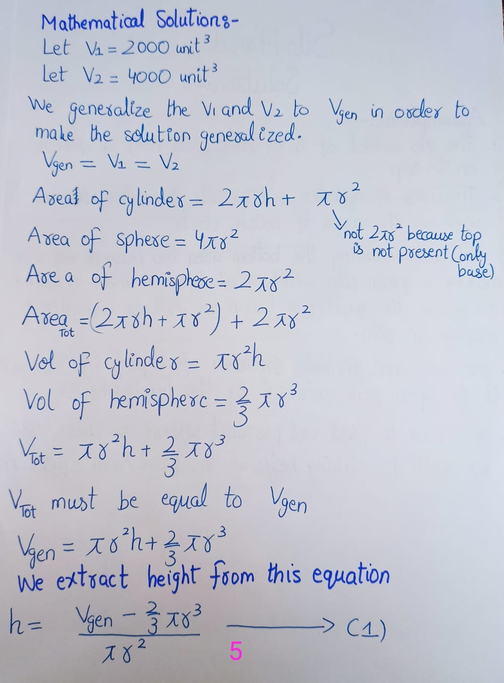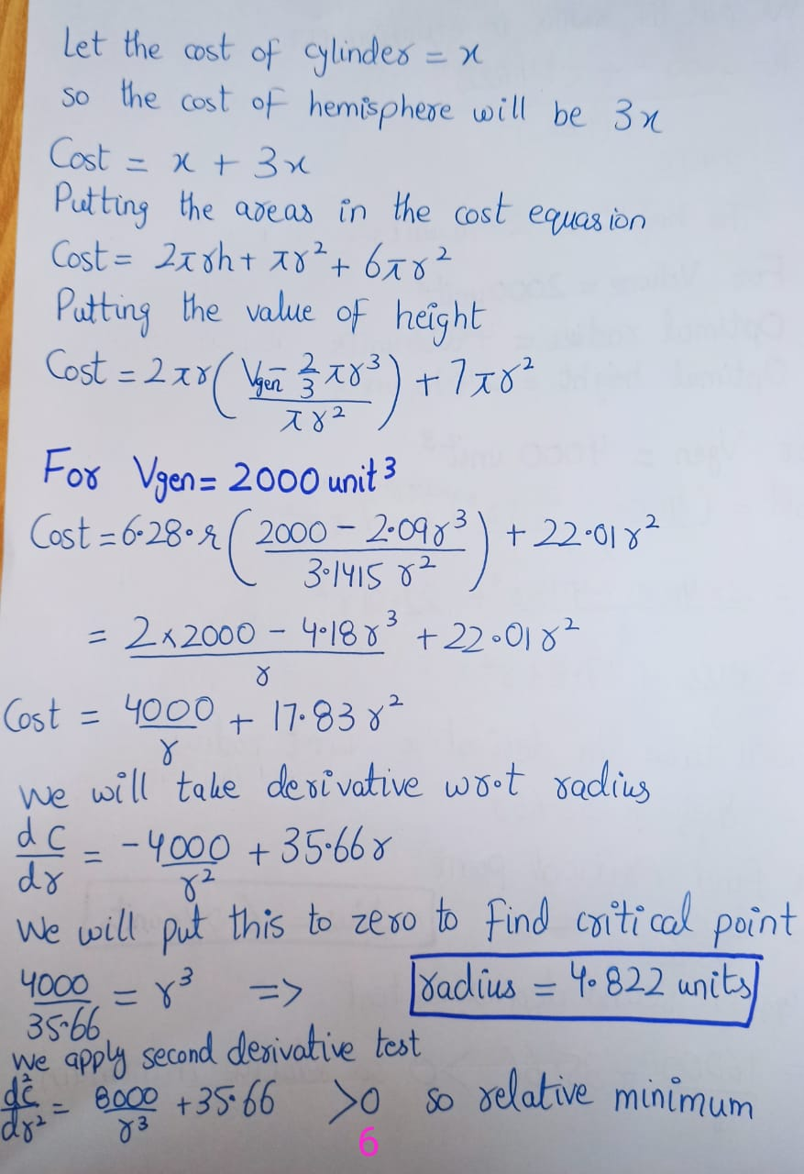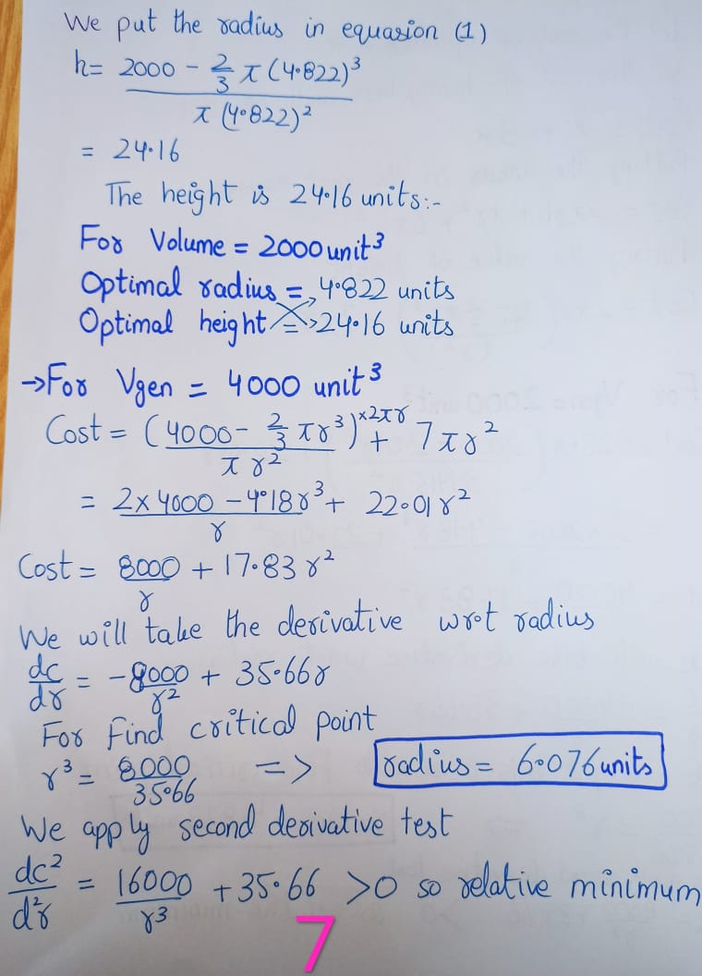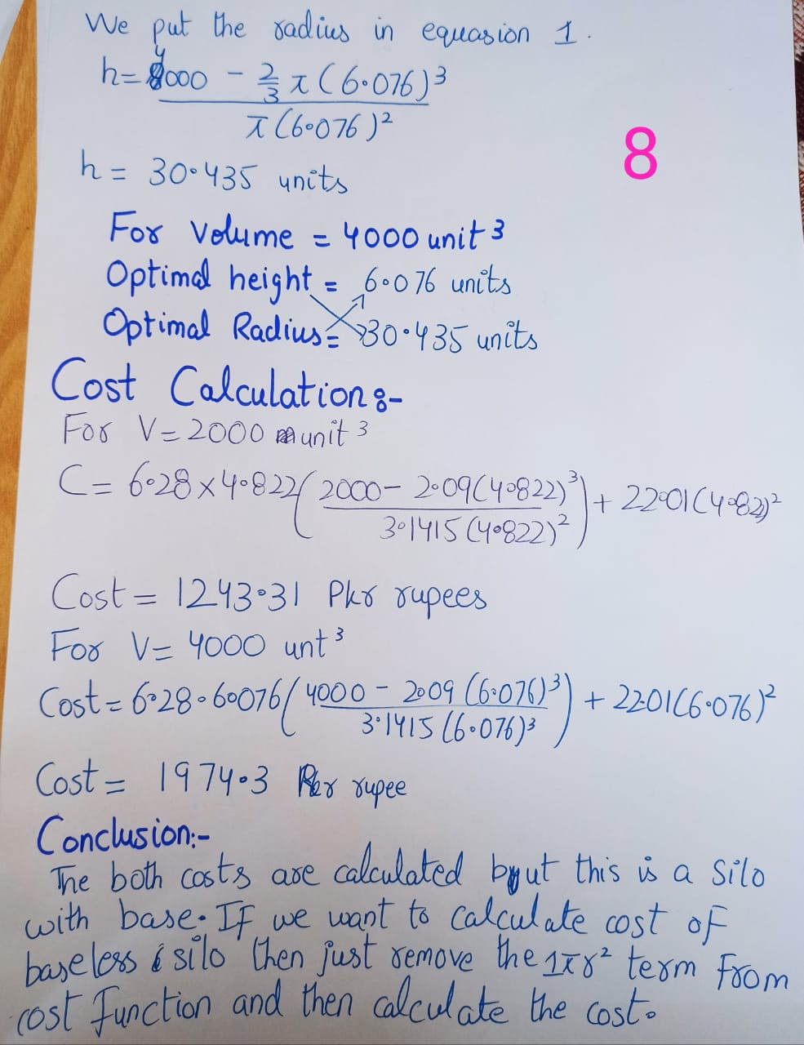3:MATLAB AND EXPLANANTION

(CODE TO BE GIVEN IN HARD FORM AS THE CODE INCLUSION CAUSED THE SIZE TO CROSS 12 PAGES)

COMMANDS EXPLANATION:

DISP: used to display

Fprintp: (display but also an easier syntax)

Input=input the value from user

IF: conditional executioner

Syms: defines the symbol of a variable

Diff: Used to differentiate the equasion

Vpa: used to display answer in decimal form

Solve: Used to solve the equasion

Else if: If “IF” is not true

Else: If “else if” is not true

End: Ends the program

CYLINDER=draws 3d cylinder

Surf=plots 3d figure with color

Sphere = code for sphere

Angle= theta for developing base of silo

Patch=draws a polygon

Set=sets properties of graphic objects

**CODE BRIEF:(LINE BY LINE EXPLANATION)**

We started with displaying each students roll numbers followed by asking the user to enter any key to start the program.After that we asked user to run the program or terminate it by an if conditional statement.

After that we displayed the three options of the program.

1.optimal cost for v1 2.optimal cost for v2 3.silo cost calculator

(FOR V1 AND V2)

We took the cost equasion from our written work and took derivative on matlab to find the radius

After we took second derivative test on hand work and verified the relative minimum.

Then we put the the radius in volumes equasion to calculate the height and volume respectively

After that we calculated the cost of the both Volumes

In last we displayed the the silo using plotting commands

(FOR CALCULATOR OPTION)

We inputted the height and radius from user

We calculated the cost and displayed it.

We also showed the figure in order for understanding

(WHEN USER SELECTS OPTION 1 FOR VOLUME=2000)

1.COST FUNCTION IS DONE MADE WITH 2000 VOLUME AND STORED IN A “COST” VARIABLE

2.COST VARIABLE DERIVATIVE AND SOLVE IS TAKEN SIMIULTANEOUSLY

NOTE(THE DERIVATIVE PROVIDED THREE ANSWERS ON MATLAB IN WHICH 1ST ONE WAS RIGHT SO I EXTRACTED IT AND VERIFIED FROM PAPER TO RUN THE NEXT COMMANDS)

3.THE ANSWER IS DISPLAYED BY VPA TO BE IN DECIMAL FORM

4.THE RADIUS IS PUT IN VOLUME EQUASION TO CALCULATE THE HEIGHT

5.THE COST IS CALCULATED THAT IS OPTIMAL COST

6.3D FIGURE OF SILO IS DISPLAYED

(WHEN USER SELECTS OPTION 1 FOR VOLUME=2000)

1.COST FUNCTION IS DONE MADE WITH 2000 VOLUME AND STORED IN A “COST” VARIABLE

2.COST VARIABLE DERIVATIVE AND SOLVE IS TAKEN SIMIULTANEOUSLY

NOTE(THE DERIVATIVE PROVIDED THREE ANSWERS ON MATLAB IN WHICH 1ST ONE WAS RIGHT SO I EXTRACTED IT AND VERIFIED FROM PAPER TO RUN THE NEXT COMMANDS)

3.THE ANSWER IS DISPLAYED BY VPA TO BE IN DECIMAL FORM

4.THE RADIUS IS PUT IN VOLUME EQUASION TO CALCULATE THE HEIGHT

5.THE COST IS CALCULATED THAT IS OPTIMAL COST

6.3D FIGURE OF SILO IS DISPLAYED

(WHEN USER SELECTED THE THIRD OPTION)

The program wanted to input radius and height from user

The program then put the radius and height from user to the cost equasion and calculated the cost of silo

3D figure of the user’s silo will also be displayed for better understanding and judgment.

**5:RESULTS SECTION:**

|  |  |  |
| --- | --- | --- |
| ***VARIABLES*** | ***MATLAB*** | ***ANALYTICAL*** |
| **V1 COST** | **1244.1** | **1243.31** |
| **V2 COST** | **1974.9** | **1974.3** |
| **V1 HEIGHT** | **24.168** | **24.16** |
| **V2 HEIGHT** | **30.442** | **30.435** |
| **V1 RADIUS** | **4.82272** | **4.822** |
| **V2 RADIUS** | **6.076258** | **6.076** |
| **SILO CALCULATOR** | **UPTO USER DATA** | **UPTO USER DATA** |

**CONCLUSIONS:**

We have made the silo optimization program with the help of second derivative test.

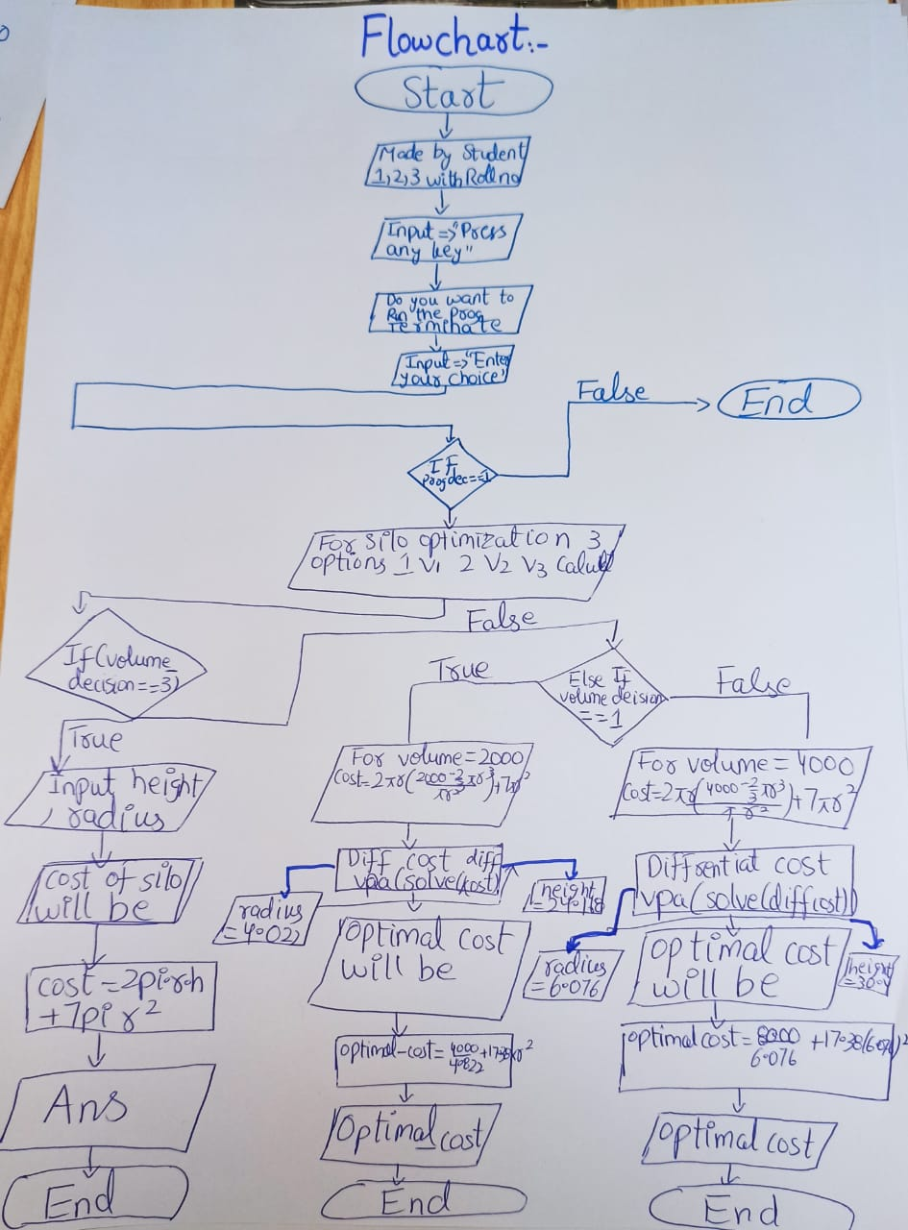We have designed the silo with a base so the grains keep safe from any water penetration and stuff.The matlab helped to visualize the silo as well as the calculation of the minimum cost.MATLAB also helped to make a program that the farmers may use for making the silo with their own height and radius.This program will aid to solve the problems faced by farmers while designing the silo.The problem we faced was deciding that whether we should make a baseless or a base silo. Moreover, we could not find the optimal answers in matlab as it showed random answers but we solved it by just assuming the value and verifying it from our paper solution

***CONTRIBUTION***:HAMZA did all the calculation work as he has a very good grip on maths and stuff. He designed the solution but it was countered by UZAIR about the base of silo so mainly the calculation was by HAMZA and UZAIR helped to correct the calculation. USMAN did the whole matlab stuff. He used a tutor of youtube to learn the whole matlab and used the commands on gcr to design the whole script of Matlab.UZAIR task was to plot the 3d figure of the silo which was quite a difficult task for him as the plot did not work and was quite new to him. Moreover he worked with HAMZA to solve the problem.